Linked-List Operations:
Insertion:
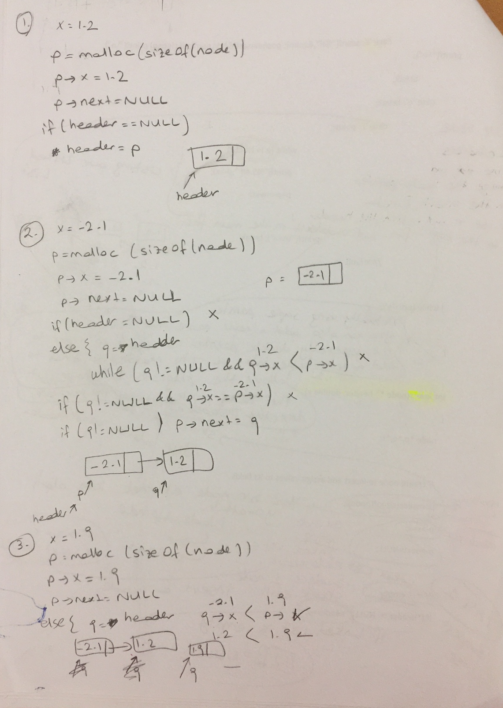
Search: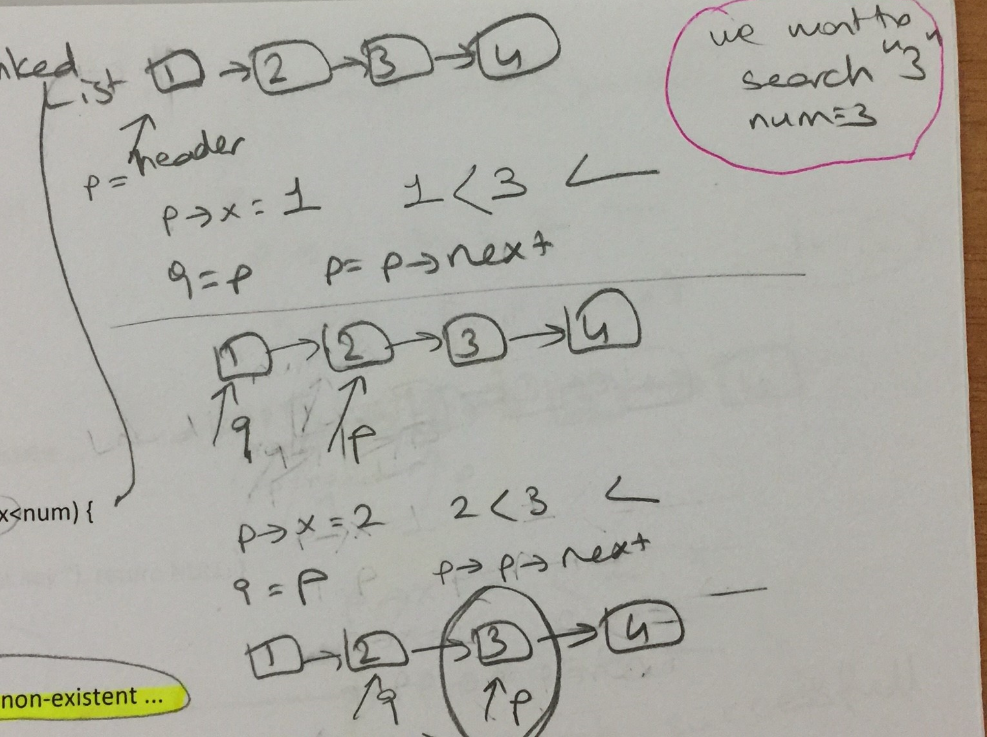

Q1. Midterm-2006 (25 pts)

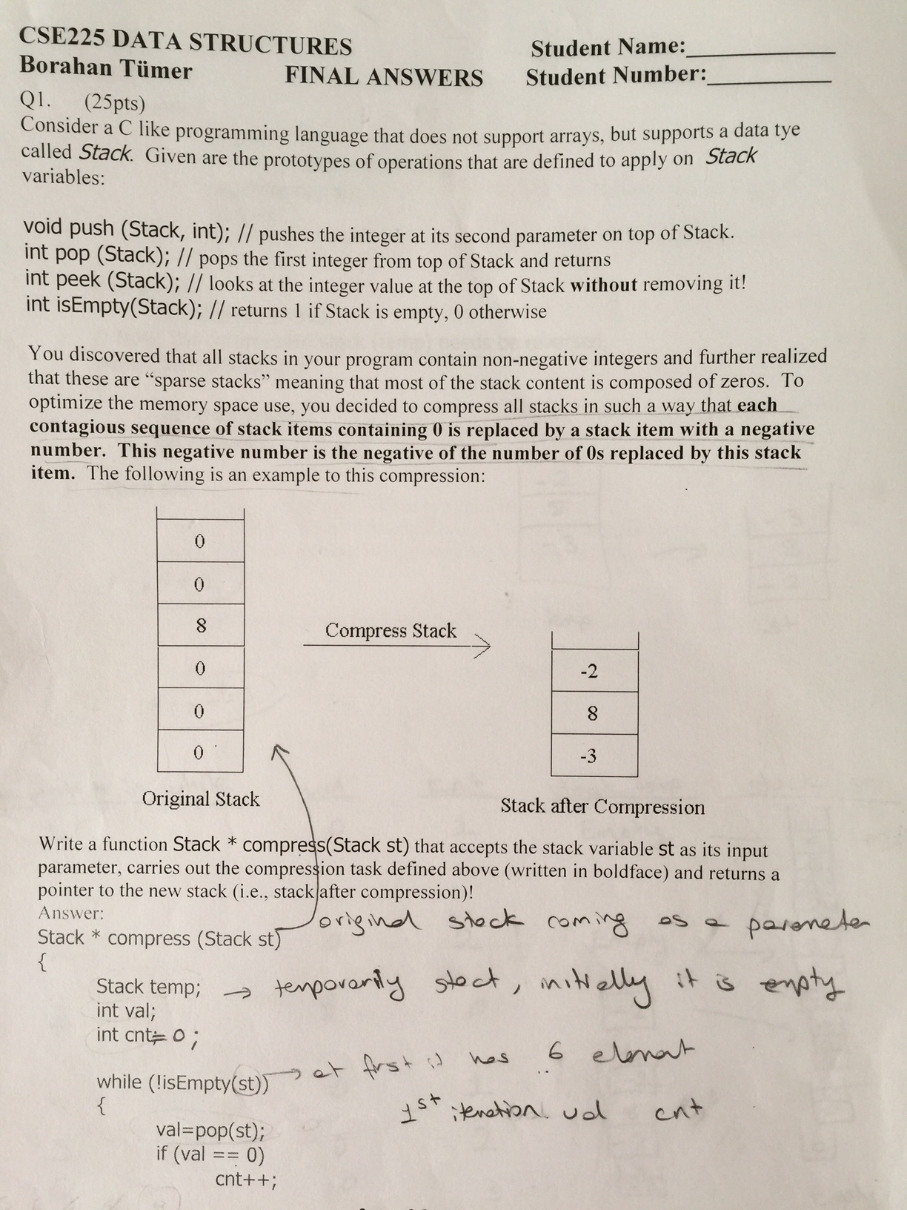

Q2.2013-Midterm (10+5=15 pts)

f(n)=4f(n/4)+d

Solve the recurrence! Also give the asymptotic upper bound (O()).

Q3. 2015 Midterm (20 pts)

Find the general solution ( t_{n}) of the following.(For full credit please show all the steps)

t_{n}= 8t_{n/4} + 12, t₁ = 3, t_{n}?

Q4. 2014-Midterm (15+5=20pts)
Consider the following piece of code!

void recfunc(int m) {
if (m < 4) {
return;
}
recfunc(m/4);
for (int j = 0; j < m; j++) printf(“%d\n”, j);
recfunc(m/2);
for (int j = 0; j < m; j++) printf(“%d\n”, j);
recfunc(m/4);
}
- Find, in terms of m, the recurrence that represents the execution time for recfunc

- Solve the recurrence with initial values f(1)=0, f(2)=0 and f(4)=8! Also give the asymptotic upper bound (O()). Show all your work!

Q5. 2008-Midterm (10 pts)
Solve the following conditional recurrence for the given initial value:

T(n)-2T(n/2)=n+log₂n; T(1)=0

